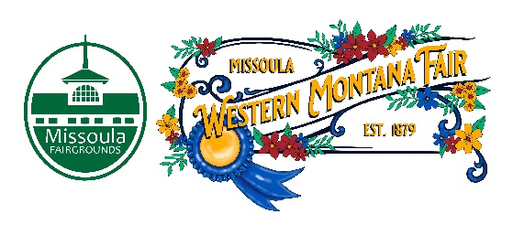

Missoula County Fair Event Committee
Thursday, June 8th, 2023, at 10:00 a.m.
Fair Office, Building #12
Missoula County Fairgrounds
1101 South Avenue West, Missoula, MT 59801

Join on your computer, mobile app or room device
Click here to join the meeting
Meeting ID: 286 977 583 829
Passcode: wVruh7
Download Teams | Join on the web

Or call in (audio only)
+1 406-272-4824,,691310245# United States, Billings
Phone Conference ID: 691 310 245#
Find a local number | Reset PIN

Committee Members

- Jim Sadler – Chair
- Dave Bell - Vice-Chair
- Sarah Knobel
- Brooke Martin
- Campbell Barrett
- Tonya Robert
- Jane Kelly
- Hailey Jo Bergstrom

Agenda

- Meeting commencement
- Rollcall & introductions
- Approval of agenda
- Action Items
- Approval of minutes from May 11, 2023
- Discussion Items
- 2023 Western Montana Fair
  - Legends Night Nominations Application Presentation
  - Entertainment Updates
  - Committee Member Bios Third-Person
  - Favorite Fair Food Judging
- Development update
  - Rodeo Arena
- Adjournment – Next meeting Thursday, July 13th, 2023, 10:00 a.m., at Missoula County Fairgrounds, Fair Office, Building #12, 1101 South Avenue W, Missoula, MT 59801.

