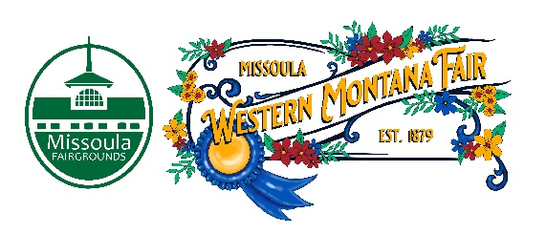

Missoula County Fair Event Committee
Thursday, March 14th, 2024, at 10:00 a.m.
Fair Office, Building #12
Missoula County Fairgrounds
1101 South Avenue West, Missoula, MT 59801
Join on your computer, mobile app or room device
Click here to join the meeting
Meeting ID: 286 977 583 829
Passcode: wVruh7
Download Teams | Join on the web
Or call in (audio only)
+1 406-272-4824,691310245# United States, Billings
Phone Conference ID: 691 310 245#
Find a local number | Reset PIN

Committee Members

- Jim Sadler – Chair
- Dave Bell - Vice-Chair
- Sarah Knobel
- Brooke Martin
- Hailey Jo Bergstrom
- Tonya Robert
- Jane Kelly
Agenda

- Meeting commencement
- Rollcall & Introductions
- Approval of agenda
- Public comment on items not on the agenda
- Action Items
- Approval of minutes from February 8th, 2024
- Discussion Items
- Western Montana Fair
  - Food Vendor Selection Committee
  - 2025 Fair Theme
  - WMF Legend 2024
  - Photoshoot
  - RFP Updates
- 4-H update
- Adjournment – Next meeting Thursday, April 11th, 2024 10:00 a.m., at Missoula County Fairgrounds, Fair Office, Building #12, 1101 South Avenue W, Missoula, MT 59801.

