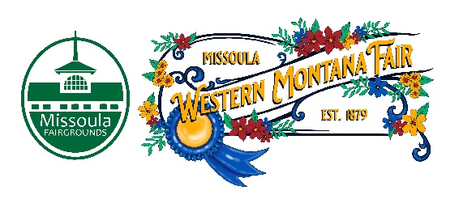

Missoula County Fair Event Committee
Thursday, October 12th, 2023, at 10:00 a.m.
Fair Office, Building #12
Missoula County Fairgrounds
1101 South Avenue West, Missoula, MT 59801

Committee Members

- Jim Sadler – Chair
- Dave Bell - Vice-Chair
- Sarah Knobel
- Brooke Martin
- Tonya Robert
- Jane Kelly
- Hailey Jo Bergstrom

Agenda

- Meeting commencement
- Rollcall & introductions
- Approval of agenda
- Public comment on items not on the agenda
- Action Items
- Approval of minutes from September 13, 2023
- Discussion Items
- 6- day fair
- Food vendor feedback
- Committee Idea
- RFP assignments
- 4-H update
- Development update
  - Grandstand demolition
  - Ribbon Cutting Ceremony
- Adjournment – Next meeting Thursday, December 14th, 2023, 10:00 a.m., at Missoula County Fairgrounds, Fair Office, Building #12, 1101 South Avenue W, Missoula, MT 59801.

