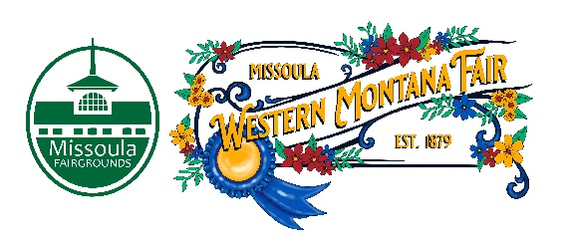

Missoula County Fair Event Committee
Thursday, March 14th, 2024, at 10:00 a.m.
Fair Office, Building #12
Missoula County Fairgrounds
1101 South Avenue West, Missoula, MT 59801
Join on your computer, mobile app or room device.

Committee Members

- Jim Sadler – Chair
- Dave Bell - Vice-Chair
- Sarah Knobel
- Brooke Martin
- Hailey Jo Bergstrom
- Tonya Robert
- Jane Kelly
Meeting Minutes

- Meeting commencement
  - Jim Sadler called the meeting to order at 10:02 a.m. Jim Sadler, Dave Bell, Sarah Knobel, Brooke Martin, Hailey Jo Bergstrom, Tonya Robert, Jane Kelly, Campbell Barrett, Billie Ayers, Allison Wilson, Jacey Grange, and Tenzin Lhaze were in attendance.
- Rollcall & Introductions
- Approval of agenda
  - Agenda has been approved for March.
- Public comment on items not on the agenda
  - None
- Action Items
- Approval of minutes from February 8th, 2024
- Discussion Items
- Western Montana Fair
  - Food Vendor Selection Committee
    - The food vendor application will be closing April 1, but the deadline may be extended. If anyone is interested in joining the food vendor committee, please reach out to Jacey. Jacey shared her concern about food vendor power. Brooke, Sarah, Tonya and Jane is interested in joining the food vendor committee.
  - 2025 Fair Theme
    - Fair staff expressed the need for 2025 Fair theme to provide to the Fair artist. 2025 Fair theme will be exploring the ice age, glacial lake Missoula. Some ideas generated are: Rodeo at the Bottom of the Lake & Glacial Lake Missoula. Fair staff will look into whether any of the themes have connotations.
  - WMF Legend 2024
    - Fair event committee made a recommendation to include previous Western Montana Legends on the website. Fair staff encouraged the fair board to submit any nominations they may have on the website.
  - Photoshoot
    - Fair staff will be refreshing the Fair event committee picture. Board pictures will take place on June 13 during the MCFEC meeting.
  - RFP Updates
    - The alcohol RFP interviews will be happening soon. This includes The Rhino, Press Box & Bamboo Bar. Interviews will be happening next Monday.
- 4-H update
  - There are more kids in 4H than in previous years. Membership is up 10% than last year. The word of the 6-day Fair is slowing getting out. There are several applications for the 4H administrator position. The position can be found on the county website.
  - Meeting is adjourned at 10:52 a.m.
- Adjournment – Next meeting Thursday, April 11th, 2024 10:00 a.m., at Missoula County Fairgrounds, Fair Office, Building #12, 1101 South Avenue W, Missoula, MT 59801.

