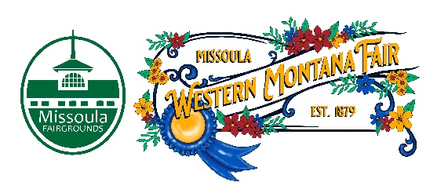

Missoula County Fair Event Committee
Thursday, December 14th, 2023, at 10:00 a.m.
Fair Office, Building #12
Missoula County Fairgrounds
1101 South Avenue West, Missoula, MT 59801

Committee Members

- Jim Sadler – Chair
- Dave Bell - Vice-Chair
- Sarah Knobel
- Brooke Martin
- Tonya Robert
- Jane Kelly
- Hailey Jo Bergstrom

Meeting Minutes

- Meeting commencement
  - Chair Jim Sadler called the meeting to order at 10:05a.m. Jim Sadler, Sarah Knobel, Brooke Martin, Tonya Roberts, Dave Bell, Billie Ayers, Allison Wilson, Jacey Grange, and Tenzin Lhaze were present.
- Rollcall & introductions
- Approval of agenda
  - Agenda has been approved for December.
- Public comment on items not on the agenda
  - None
- Action Items
- Approval of minutes with one change that it was not an opt-in but a return to opt-in.
- Discussion Items
- RMAF convention report
  - Allison and Dave attended the RMAF. Allison networked with people in the industry, attended workshops on sponsorships, fairgrounds foundation and vendors. She also toured the N. Idaho fairgrounds and picked up information on Fair premium books. Dave attended a workshop on livestock care.
- IAFE convention report
  - Jacey and Billie went to IAFE. Jacey attended a workshop on food safety and on developing an emergency action plan. She also learned about a March Madness food vendor engagement tool and wants to incorporate it this year. Jacey and Billie networked with the Bozeman Fair team and shared information on how to do things better.
- NFR convention report
  - Allison and Billie attended the NFR. Allison went to a workshop on animal welfare and on developing a PRCA youth rodeo team program. Billie went to a workshop on PR and social media. Billie noted that there was no decision make on the stock contractor yet, and that she will be meeting with Dave Wall to work out the final details.
- 4-H update
  - None.
- Development update
  - Grandstands
    - Grandstands are down. The demolition was ahead of schedule. The Fairgrounds Foundation received a $60,000 donation from the Gallagher Foundation.
- Adjournment
  - Meeting adjourned at 10:43 am. Next meeting with be Thursday, January 11th, 2024, 10:00 a.m., at Missoula County Fairgrounds, Fair Office, Building #12, 1101 South Avenue W, Missoula, MT 59801.

